**WEB Based Application Development**

**-**

**Tutorial**

1.

Create the following Registration Form and

display the values of the

input fields as shown below

using HTML, CSS & PHP.

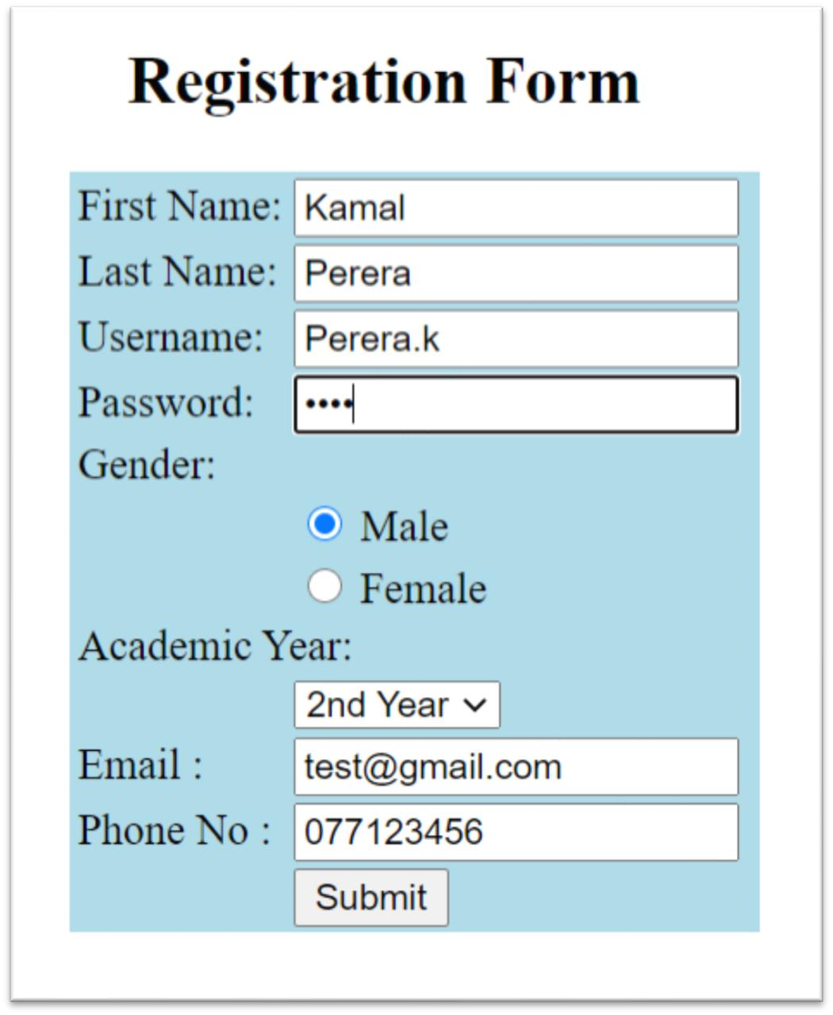

Html file

<!-- http://localhost/PHP2/index.html -->

<!DOCTYPE html>

<html>

<head>

<title>Registration Form</title>

<style>

body {

font-family: Arial, sans-serif;

margin: 20px;

}

.registration-form {

border: 1px solid #ccc;

padding: 20px;

max-width: 300px;

}

.form-row {

margin-bottom: 10px;

}

.form-row label {

display: inline-block;

width: 120px;

}

</style>

</head>

<body>

<div class="registration-form">

<h2>Registration Form</h2>

<form action="process_form.php" method="post">

<div class="form-row">

<label>First Name:</label>

<input type="text" name="first_name" required />

</div>

<div class="form-row">

<label>Last Name:</label>

<input type="text" name="last_name" required />

</div>

<div class="form-row">

<label>Username:</label>

<input type="text" name="username" required />

</div>

<div class="form-row">

<label>Password:</label>

<input type="password" name="password" required />

</div>

<div class="form-row">

<label>Gender:</label>

<input type="radio" name="gender" value="Male" required /> Male

<input type="radio" name="gender" value="Female" required /> Female

</div>

<div class="form-row">

<label>Academic Year:</label>

<select name="academic_year" required>

<option value="1 Year">1 Year</option>

<option value="2 Years">2 Years</option>

<option value="3 Years">3 Years</option>

</select>

</div>

<div class="form-row">

<label>Phone No:</label>

<input type="text" name="phone_no" required />

</div>

<div class="form-row">

<input type="submit" value="Submit" />

</div>

</form>

</div>

</body>

</html>

Php file

<!DOCTYPE html>

<html>

<head>

<title>Registration Form - Output</title>

<style>

body {

font-family: Arial, sans-serif;

margin: 20px;

}

.output-table {

border-collapse: collapse;

width: 300px;

}

.output-table th,

.output-table td {

border: 1px solid #ccc;

padding: 8px;

}

</style>

</head>

<body>

<?php

if ($_SERVER["REQUEST_METHOD"] == "POST") {

$first_name = $_POST["first_name"];

$last_name = $_POST["last_name"];

$username = $_POST["username"];

$password = $_POST["password"];

$gender = $_POST["gender"];

$academic_year = $_POST["academic_year"];

$phone_no = $_POST["phone_no"];

?>

<h2>Registration Form - Output</h2>

<table class="output-table">

<tr>

<th>First Name</th>

<td><?php echo $first_name; ?></td>

</tr>

<tr>

<th>Last Name</th>

<td><?php echo $last_name; ?></td>

</tr>

<tr>

<th>Username</th>

<td><?php echo $username; ?></td>

</tr>

<tr>

<th>Password</th>

<td><?php echo $password; ?></td>

</tr>

<tr>

<th>Gender</th>

<td><?php echo $gender; ?></td>

</tr>

<tr>

<th>Academic Year</th>

<td><?php echo $academic_year; ?></td>

</tr>

<tr>

<th>Phone No</th>

<td><?php echo $phone_no; ?></td>

</tr>

</table>

<?php

}

?>

</body>

</html>

Once the submit button of the Registration form is clicked, the

output

should display like this

